ITA0601 – MACHINE LEARNING
LAB EXPERIMENTS
Exp-1: Implementation of FIND-S Algorithm
Aim:
To implement and demonstrate the FIND-S Algorithm for finding the most specific hypothesis that is consistent with the given set of positive training examples.
Procedure:
- Import the pandas library.
- Create a training dataset containing attributes and the target class.
- Separate the attributes (X) and target values (Y).
- Initialize the hypothesis with the first positive training example.
- Traverse through all the training examples.
- If the training example is positive:
  - Compare each attribute with the hypothesis.
  - If they are different, replace that attribute in the hypothesis with "?".
- Ignore all negative examples.
- Display the final hypothesis after processing all training samples.
Python Code:
import pandas as pd
data = {
'Sky': ['Sunny', 'Sunny', 'Rainy', 'Sunny'],
'AirTemp': ['Warm', 'Warm', 'Cold', 'Warm'],
'Humidity': ['Normal', 'High', 'High', 'High'],
'Wind': ['Strong', 'Strong', 'Strong', 'Strong'],
'Water': ['Warm', 'Warm', 'Warm', 'Cool'],
'Forecast': ['Same', 'Same', 'Change', 'Same'],
'EnjoySport': ['Yes', 'Yes', 'No', 'Yes']
}
df = pd.DataFrame(data)
print("Training Dataset:\n")
print(df)
X = df.iloc[:, :-1].values
Y = df.iloc[:, -1].values
for i in range(len(Y)):
if Y[i] == "Yes":
hypothesis = X[i].copy()
break
for i in range(len(X)):
if Y[i] == "Yes":
for j in range(len(hypothesis)):
if hypothesis[j] != X[i][j]:
hypothesis[j] = "?"
print("\nFinal Hypothesis:")
print(hypothesis)
Output:
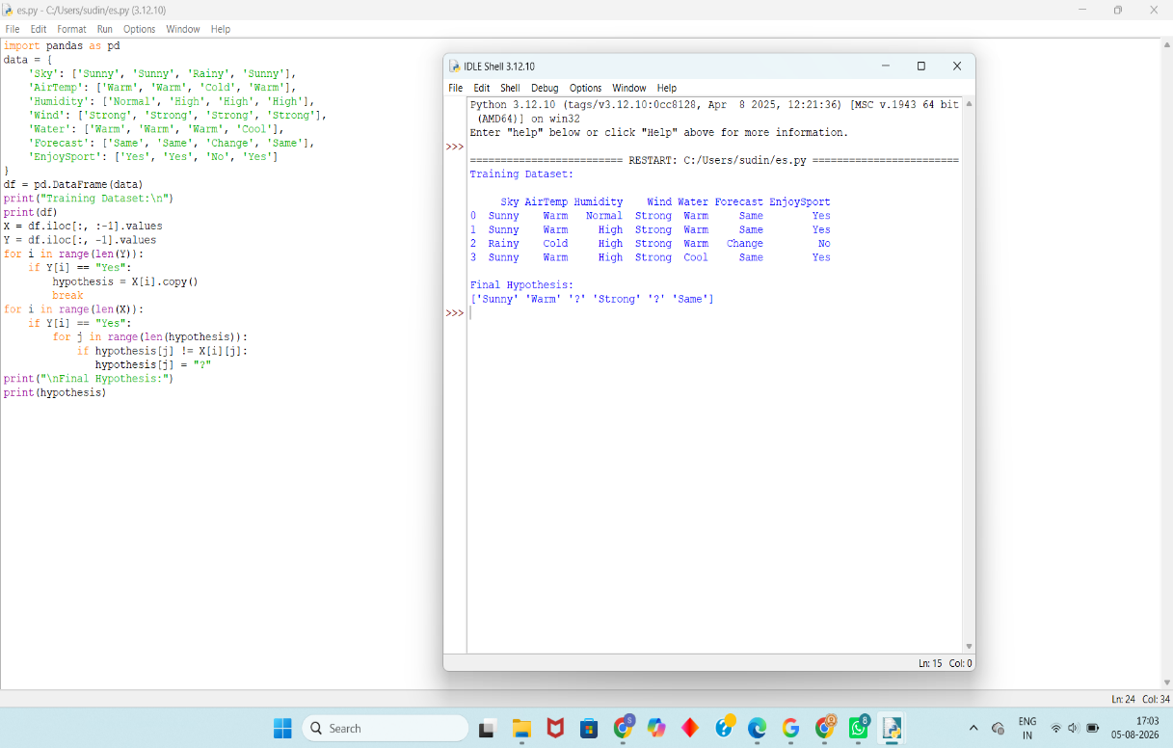
Result:
The FIND-S Algorithm was successfully implemented in Python. The algorithm examined only the positive training examples and produced the most specific hypothesis consistent with all positive examples.

